Product Overview
The File Integrity Monitoring and Alert System is a lightweight cybersecurity solution designed to detect unauthorized file modifications, deletions, and additions. The system uses SHA-256 hashing to establish a trusted baseline of monitored files and compares future scans against this baseline to identify integrity violations.

Problem Statement
Organizations often lack affordable tools to monitor critical files and detect unauthorized changes. This can result in data tampering, accidental deletions, insider threats, or malware activity going unnoticed.

Target Users
Small and medium-sized businesses, educational institutions, healthcare facilities, IT administrators, and cybersecurity practitioners.

Product Objectives
Create file baselines, monitor file integrity, detect modified/deleted/new files, generate alerts, maintain logs, and produce audit reports.

Key Features
- Folder selection and monitoring
- SHA-256 baseline creation
- Modified file detection
- Deleted file detection
- New file detection
- Alert generation
- Log file generation
- Integrity report generation

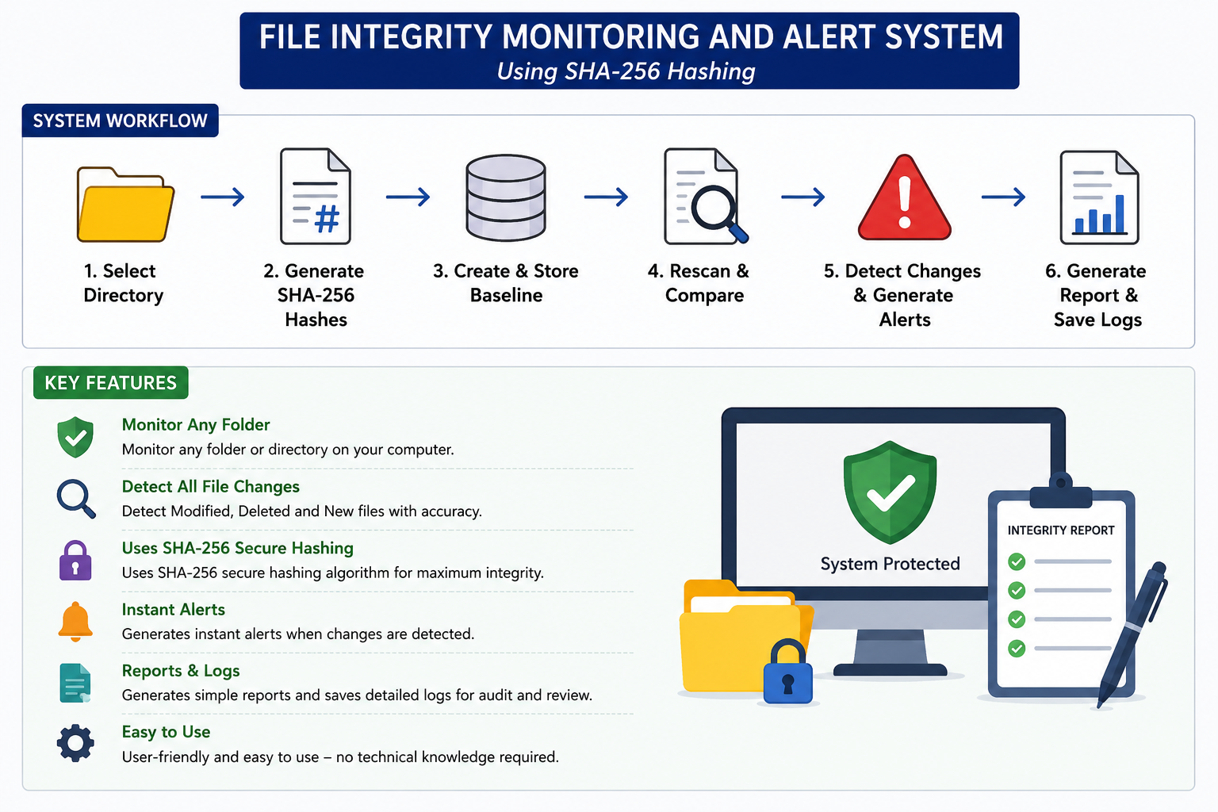

System Workflow
Select folder → Generate baseline hashes → Store baseline → Rescan folder → Compare hashes → Detect changes → Generate alerts → Save logs and reports.

Technology Stack
Python, hashlib (SHA-256), JSON storage, text-based logging and reporting, Visual Studio Code.

Benefits
Improves data integrity, supports auditing, provides early warning of unauthorized changes, and demonstrates practical cybersecurity concepts.

Hello world

